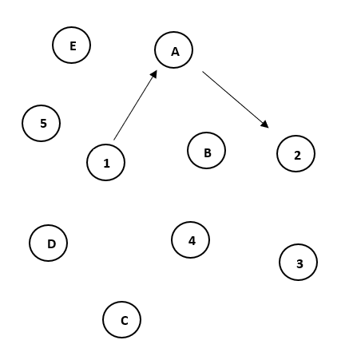 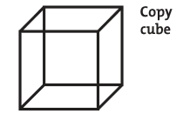

[ ] [ ]

**In the space below, draw a clock with the hands at ten past eleven.**

**Name the animals in the pictures below.**

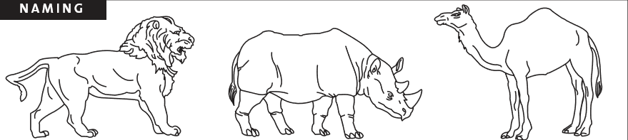

[ ] [ ] [ ]

**Have subject repeat the following words. Do two trials.**

**FACE** [ ] [ ] **Velvet** [ ] [ ] **Church** [ ] [ ] **Daisy** [ ] [ ] **Red** [ ] [ ]

**Read the following lists of digits:**

1. Repeat the following in the forward order: **2, 1, 8, 5, 4**  [ ]
2. Repeat the following in the backward order: **7, 4, 2** [ ]

**Read the list of letters. Subject has to tap their hand each time they hear the letter “A”:**

* F B A C M N A A J K L B A F A K D E A A A J A M O F A A B [ ]

**Starting at 100, have subject count back by 7’s:**

* 93 [ ] 86 [ ] 79 [ ] 72[ ] 65 [ ]

**Have subject repeat the following:**

* I only know that John is the one to help today. [ ]
* The cat always hid under the couch when the dogs were in the room. [ ]

**Have subjects name as many words as they can in one minute that start with the letter F:**

* [ ] _____ (N >= 10 words)

**Have subjects describe similarity between the following objects:**

* Train – Bicycle [ ] Watch – Ruler [ ]

**Delayed Recall:**

* **Face** [ ]  **Velvet** [ ] **Church** [ ] **Daisy** [ ] **Red** [ ]

**Orientation:**

* **Date** [ ] **Month** [ ] **Year** [ ] **Day** [ ] **Place** [ ] **City** [ ]